Help us stay safe

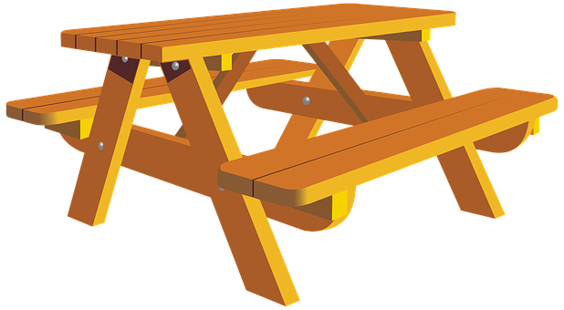

Outdoor furniture and fixtures are not cleaned regularly.

Please take your own precautions.

