Help us stay safe
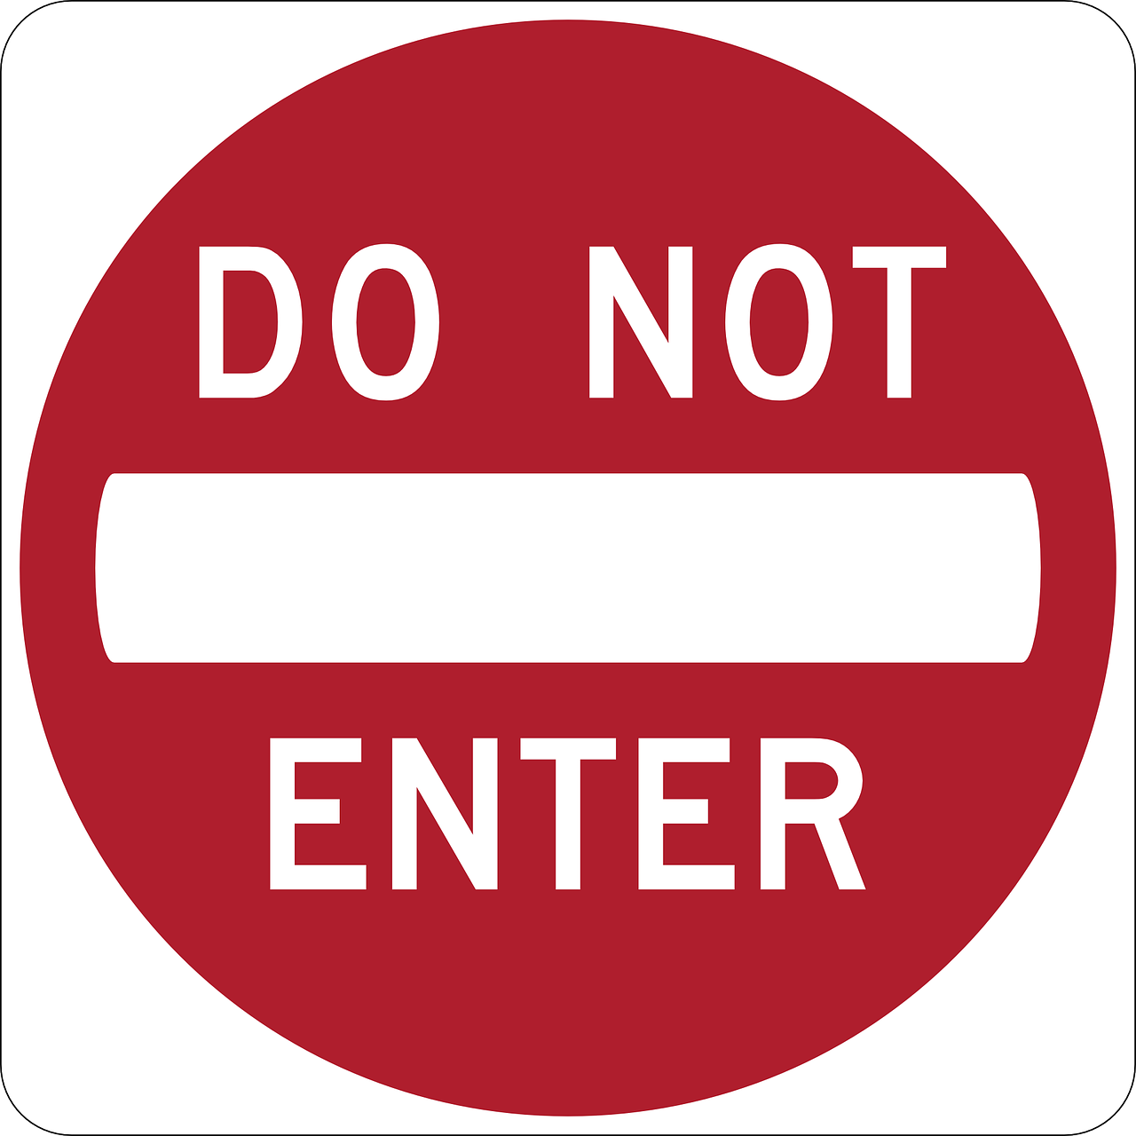

Please knock & wait for an answer.
Only enter if no response is received.

Please be aware of users who may be hard of hearing, etc. and return outside to wait if required.

