

**Help us stay safe**

**Sanitise your hands on entry**

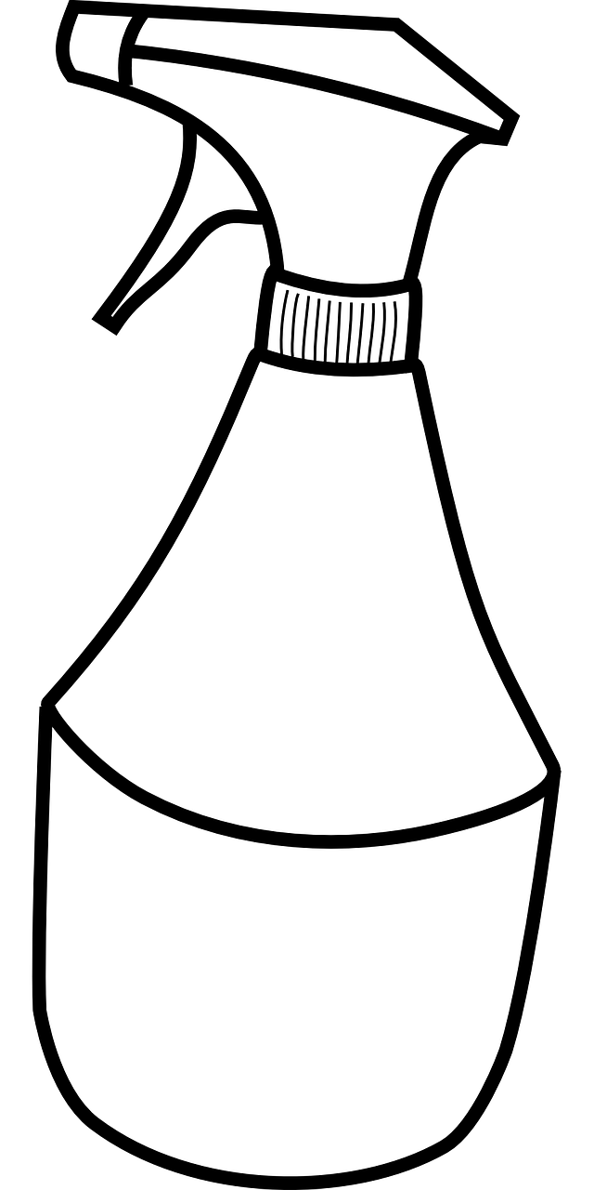

**Clean surfaces before exiting**