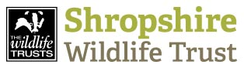
Date Thursday 13th September 2018
Dear Sirs,
RE: PROJECT NUMBER: R0012
PROJECT NAME: River Friendly Shropshire – Citizen science River health app
Please find enclosed tender documents inviting you to submit a tender for design and development of a citizen science river health sampling, recording and reporting App.

The completed Schedule of Works, Form of Tender, Anti Collusion Certificate, Contractor’s Competence Questionnaire and Environmental Protection Act 1990 form are to be sealed in the envelope provided and delivered or sent by post in accordance with the enclosed instructions to reach this office not later than on Monday 1st October 2018. You are advised to read the tender conditions carefully as all requirements will be strictly enforced.

The works are to commence as soon as possible/date and must be completed by no later than 31st March 2019. The successful tenderer will be invited to attend a pre-mobilisation meeting during the week before commencement of works. Unsuccessful tenderers will be notified by email.

Please do not hesitate to contact me if you require additional information or have any queries relating to this tender.

I look forward to hearing from you,

Yours sincerely
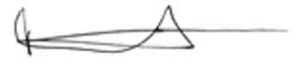
Pete Lambert
River Projects Manager, Shropshire Wildlife Trust

River Friendly Shropshire Project is funded by the
Shropshire Wildlife Trust, 193, Abbey Foregate, Shrewsbury, Shropshire SY2 6AH
Company Reg. No. 729746 Charity No. 212744 VAT No. 594216525

